**How to Play Map It! World Edition**

**Setup**

* Place the compass rose card in the middle of the table.
* Each player takes four tokens.
* Choose whether you are going to use just the beginner cards or the beginner and expert cards. If you chose just the beginner cards, you will only use the cards that have a black bar above and below the city name. Shuffle the chosen cards.
* Separate the cards into three piles of fifteen cards.
* Choose one of the piles to start the game with. Set the other two piles aside for the second and third rounds. Take the top card from the chosen pile and place it in the center of the compass rose card. Set the other cards next to the compass rose card.
* Randomly determine which player will start the game.

[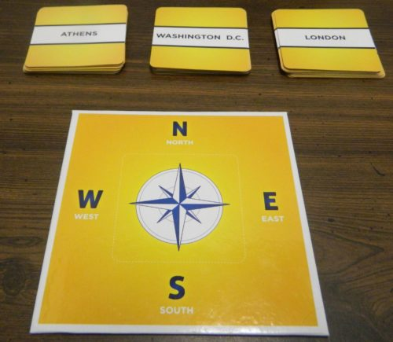](https://www.geekyhobbies.com/wp-content/uploads/2018/08/Map-It-Setup.jpg)

**Playing the Game**

**Playing A Card**

On a player’s turn they take the top card from the current pile. Without looking at the back of the card the player has to decide whether the location on the cards is north, east, south or west of the card on the compass rose card. They will place the card in the corresponding direction relative to the center card. As long as no one challenges the placement, play passes to the next player clockwise.

[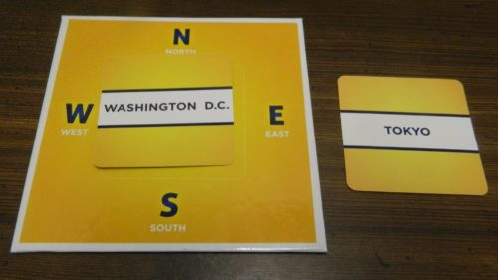](https://www.geekyhobbies.com/wp-content/uploads/2018/08/Map-It-Placing-Card.jpg)

This player believes Tokyo is east of Washington D.C. so they place the card to the right of the middle card.

Each player takes turns placing the next card from the pile. All cards must be placed in accordance to all of the cards on the table.

[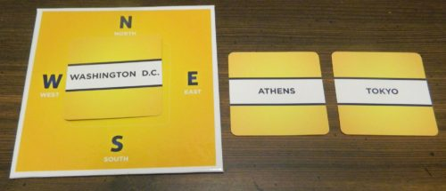](https://www.geekyhobbies.com/wp-content/uploads/2018/08/Map-It-Place-Second-Card.jpg)

With the Tokyo card already on the table, this player decided to place the Athens card between Washington D.C. and Tokyo. This player believes that Athens is east of Washington D.C. and Tokyo is east of Athens.

**Challenging A Card**

After a player has played a card, the other players are able to challenge the position of the card if they believe it was placed incorrectly. Going clockwise around the table each player can choose whether to challenge or not. If one of the players challenge the placement they will flip over the card and one of the adjacent cards.

[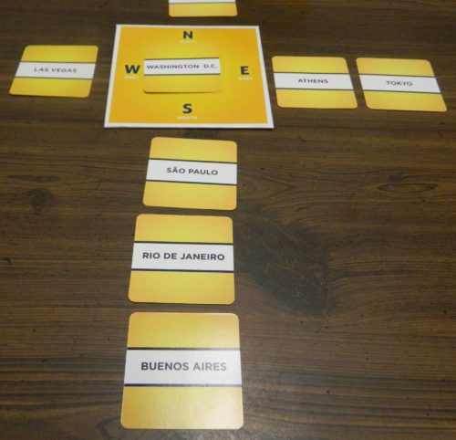](https://www.geekyhobbies.com/wp-content/uploads/2018/08/Map-It-Challenge-Card-1-1.jpg)

The current player has placed the Rio De Janeiro card below the Sao Paulo card. One of the players decide to challenge this placement as they think Rio De Janeiro is north of Sao Paulo.

To compare the cards use the white marks along the sides of the cards.

* To compare cards north to south, place the cards next to one another horizontally. The card whose line is further up on the card should have been placed above the other card.
* To compare cards east to west place one card above the other. Whichever card’s line is further left should have been placed to the left of the other card.
* If the lines are basically equal to one another, the players will have to compare the coordinates on the cards to see if the cards were placed correctly.

[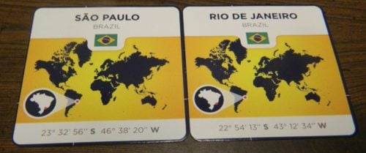](https://www.geekyhobbies.com/wp-content/uploads/2018/08/Map-It-Challenge-Card-2.jpg)

A player challenged the placement of the Rio De Janeiro card as they believed it is north of Sao Paulo. The players first compare the lines on the right/left side of the cards. Since the lines are practically at the same place, the players compare the coordinates. By comparing the coordinates they confirm that the challenger was correct that Rio De Janeiro is north of Sao Paulo.

If the card was placed incorrectly, the cards are flipped (unless one of the cards were the center card). The player who incorrectly placed the card will give one of their tokens to the challenging player. If the card was placed correctly the challenging player has to give one of their tokens to the player who placed the card.

**End of Round**

After all of the cards from one of the piles have been played, the round ends. All of the players will look at the cards that have been placed. Each player will predict how many cards they believe were placed incorrectly. At the same time each player holds up fingers equal to how many cards they think were placed incorrectly. The players will then compare all of the cards to see if they were placed correctly. The players will start with the center card and move one card at a time in each direction checking each card against the next card. If any cards were placed incorrectly they are removed from the table.

[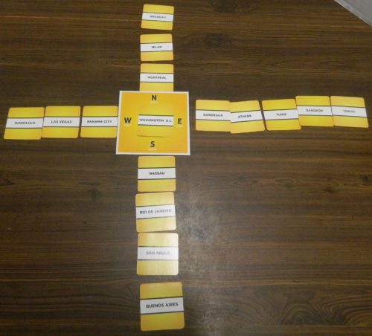](https://www.geekyhobbies.com/wp-content/uploads/2018/08/Map-It-End-of-Round.jpg)

All of the cards for this round have been placed. Each player has to guess how many cards they think were misplaced.

Once all of the cards have been checked the players will count up how many were removed from the board. If any player(s) correctly guessed how many cards were placed incorrectly, they will take two tokens from the bank. If none of the players guessed correctly, the player(s) whose guess was closest will take one token from the bank.

All of the cards used in the round are discarded. The players choose one of the remaining piles and place the top card on the compass rose card and another round is played.

**End of Game**

The game ends when all three rounds have been finished. The players count up how many tokens they acquired in the game. The player with the most tokens wins the game.